Logic of sjf:

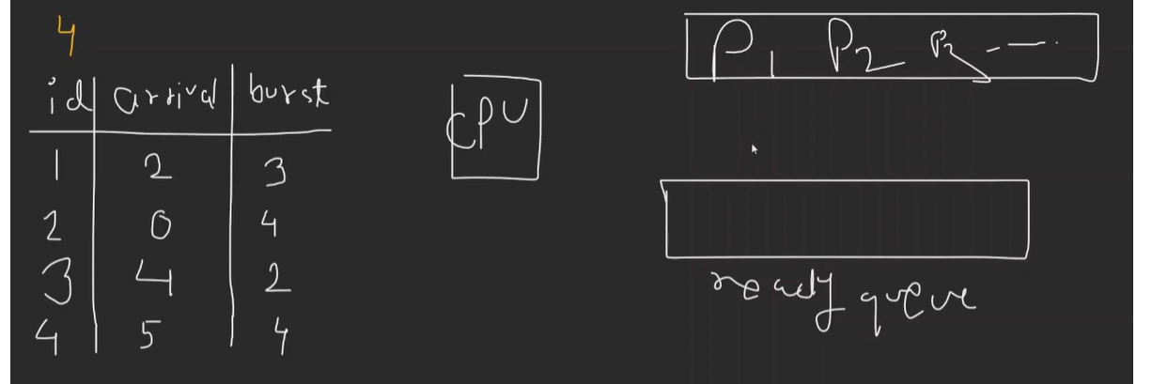

See here we don’t know which will be executed first. See here whichever job has lowest burst time will be executed first. See burst time is execution time.

See here min burst time is 3 id .but the arrival time is 4 and hence we will not wait for the arrival time we will take another .here hence we will take which has first come.

But if arrival time is same then we will take which has the min burst time.

We will dry run according to our logic.

See at t=0 we have id 2 coming. Here burst time is 4. hence we need to take all the id whose arrival time is 4 or less in ready queue. Hence 1 and 3 will be taken.

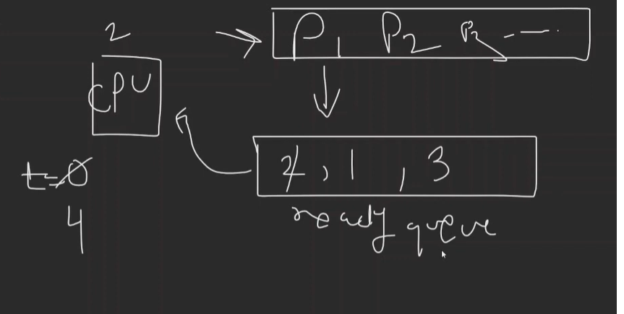

Now 2 will be released.1 and 3 take min burst time and use in time. Here burst time is 2 and hence 4+2 that is 6 will be taken. Hence id 4 will be taken and hence use the same with min burst time in the queue and release earlier.

Here 2 3 1 4 will be the order our process been executed.

Code:

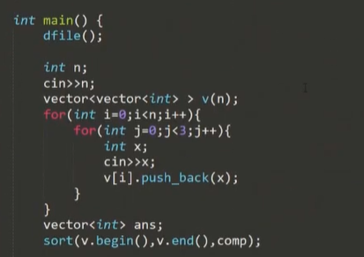

See here in v[0] we have id,v[1] has arrival time and v[2] has burst time.

See sort first by arrival time. If arrival time same take burst time min. if both same, then take id.